Dhaswinth B.H

[dhaswinth.b@indiumsoft.com](mailto:dhaswinth.b@indiumsoft.com)

**Programming Basics**

**Finding second largest number:**

**Algorithm:**

1. Start
2. Create a list with certain values (list1)
3. Sort the list1
4. As we required second largest number, use [-2] index value
5. The answer will be printed along with the print statement
6. Stop

**Flowchart:**

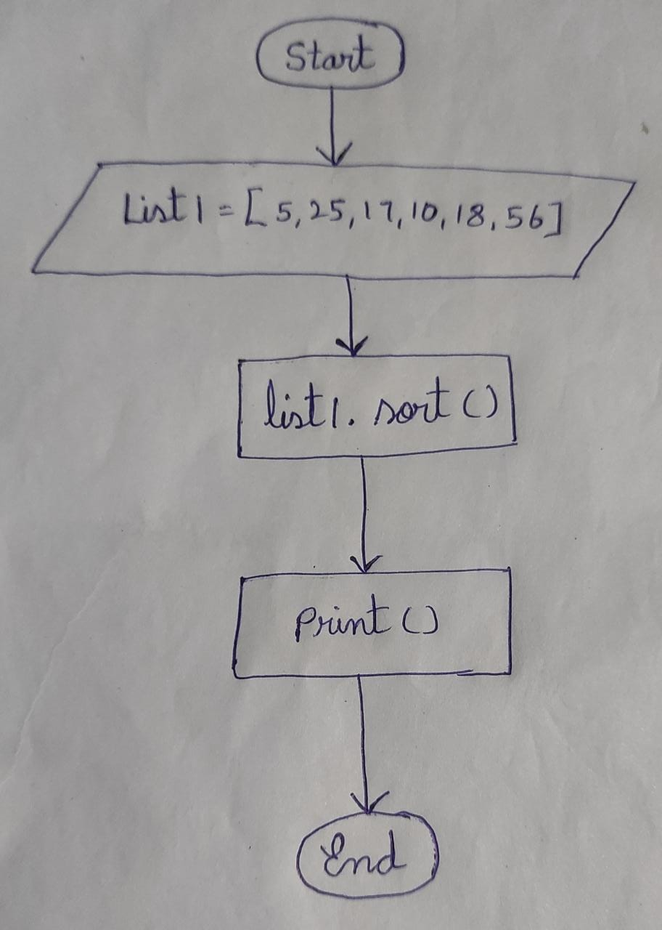

**Program:**

list1 = [5, 25, 17, 10, 18, 56]

list1.sort()

print("The second largest number in the list is:", list1[-2])

**Output:**

The second largest number in the list is: 25